EXECUTIVE SUMMARY
Project Overview

Problem /Opportunity
Education is globally recognized as one of the pillars of national achievement, growth and development. Jamaica’s education continues to underperform in spite of a succession of policy changes and experiments. The system hasn’t inspired students or provide a source of innovation and transformation.
Solution:
Studies and evidence have shown that the integration of appropriate technology can provide solution to some of the aforementioned problems, even given the poor infrastructure. Technology stimulate interest and can be adapted to a variety of learning styles.
Education Industry:
The multi-tiered structure of the education market increases the importance of each level from early childhood to Life-Long Learning sectors. The growth of the market far outstrips its carrying capacity. The Mico University College ‘s over one hundred and eighty years in the business of training teachers give it a key perspective and position to lead solution initiatives. This will avoid being overwhelmed by the problem.
Competition:
This competitive advantage built on our competence cannot be protected by inertia. Several overseas universities have entered and is increasingly being embraced by our students. The benefits of competition have not escaped our attention. The lack of resource inhibits our response.

Business Model:
Selective Partnering is a strategy that provide numerous benefits. This partnership will leverage our strengths and unique knowledge of the customers and other stakeholders to create and deliver inherent value. This can begin to offer solutions to some of our society’s challenges, i.e., socioeconomic stability, sustainable growth and innovation leadership.
The project will be owned and managed by a structure to include partners and other stakeholders. This group of trained and experienced professionals combined with the expertise of partners’ representatives will guide the operation of the project ensuring that goals and objectives are fulfilled in a timely and efficient manner.
Financial Cost;
The creation of one (1) SMART room is estimated at 9 million Jamaican dollars.
Value proposition:
Mico SMART project will create, communicate and deliver uncontestable value to our students, participants and partners which will become an installment in their legacy of reversing and returning our society to a place of prominence in the community of developing countries.
The benefits of supporting this initiative will deliver returns through an extensive professional network of current, past and connected Mico fraternity.
Conclusion:
This investment in a Smart Room will strengthen teacher education and provide strategic support to socioeconomic development and crime reduction intervention through our outreach initiatives.

PROJECT PROPOSAL
Project Title: Partnership between MOSA New York and The Mico University College for the Establishment of an Interactive Smart Room
Background and Rationale:
Preparing Jamaicans to harness all the potential of technology, begins with the correct native environment. The National e-learning project has had limited success in its implementation, due to the inability of schools to harness the capabilities embedded in the use of technology. A critical starting point is therefore to provide the conditions necessary for the teacher/facilitator to contribute to the integration of methodologies, resources and learning activities that contribute to making learning and teaching successful.
The Mico University College has taken the first steps in its quest to create Smart classrooms using pedagogical design which will articulate, and maximize, the different dimensions of the learning space so as to capitalize on its benefits. Smart classrooms are generally associated with organizing and enhancing learning spaces in institutions to the extent where the best conditions for learning, physical and methodological, are generated in the most efficient and satisfactory way possible for all agents involved in the process. With the completion of our SMART Campus project, access to Smart/interactive technologies will become a basic component of the teacher’s/facilitator’s experience in the preparation of learners for the modern world.
The Mico has established five (5) Smart rooms so far and is seeking partnership with you to complete another Smart room.
Relevance of the Partnership between The Mico University College and MOSA New York
The Mico University College has positioned itself strategically to lead the process of integrating modern technologies into teaching/training by developing smart rooms that will transform the education landscape. Likewise, MOSA New York Chapter in its quest to provide quality services to students of The Mico University College and its alumnus to become a household name as a supportive organization. A partnership, MOSA New York and The Mico, will contribute to a more targeted use of technology to meet the needs of citizens, thereby creating more opportunities for the integration of technology in their everyday lives.
This product is anticipated to become an agent of transformation of Jamaicans to become astute professionals and proficient leaners via the use of modern technologies.
Methodology
The Mico University College intends to execute this partnership with the MOSA New York using the following strategies:
- The upgrading of a selected regular classroom into a modern Smart Rooms at The Mico University College. The room will be outfitted with modern interactive technologies to facilitate the delivery of online and face-to-face training.
- Developing professional development programs targeting the training of young people in surrounding communities as an intervention to improve their productivity and professionalism on the job. The training programs will be designed and delivered using a Learning Management System (MOODLE) to accommodate distance learning, the integration of both modern technology tools and pedagogy.
- Developing special mentorship programs that will target the transforming of young people into successful professionals’/business men and women. The Smart rooms will allow this training to act as an intervention for the training of young people across Jamaica in areas such as entrepreneurship, business development, skills training, etc.

Financial Sustainability
It is anticipated that the completed Smart rooms could be offered to other institutions/organizations to conduct training at an established cost. Also, the courses developed for the professional development training could be offered as modular courses online to the general public at a cost. This income generating component of the project will contribute significantly to the maintenance the equipment in the rooms.

Institutional Capacity Assessment for Implementation of Project
The Mico University College is proposing that a formal structure of project meetings including both parties be established to manage the implementation of the project. The Project team will:
- Develop a project plan to guide the execution of the project;
- Manage the execution of the project;
- Establish mechanisms for the monitoring and evaluation of the project and the status of the partnership accordingly;
- Explore other opportunities for both parties to collaborate on agreed initiatives.

The Cost of Creating a Smart Room
There are two components to the refurbishing of a room. These components include upgrading the infrastructure of the room and the other component involves installation of the various technological devices.
Picture of Existing Smart Room at The Mico University College

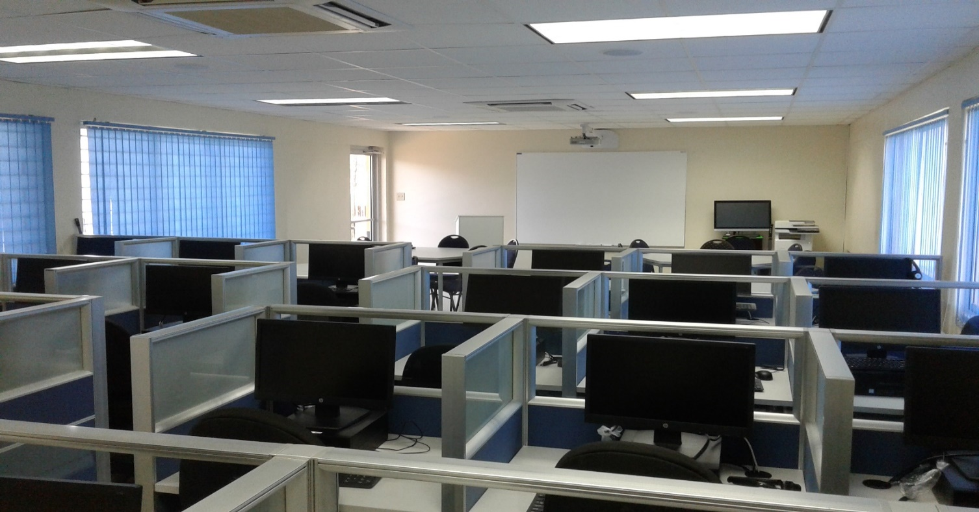
Projected Cost

Description | Cost (JMD)
To remove existing windows, tiles, grills and cart away to approved dump site; to perform masonry works | 198,500.00
To supply block, sand, steel, cement, etc | 100,690.00
To dig flooring and walls to accommodate electrical pipes and fittings and cart away debris to approved dump site | 145,000.00
To supply Tiles, Thinset and Grout for the room | 153,200.00
To install tiles | 80,000.00
To supply paint for the room | 35,000.00
To paint the room | 30,000.00
To supply and install windows and doors | 547,659.00
To supply acoustic ceiling material | 287,248.00
To install acoustic ceiling | 64,000.00
To supply and install Air Conditioning Units | 616,584.43
To supply electrical fixtures and material for the room | 304,310.40
To install electrical panel, light fixtures, plugs and conduit for network cable | 120,000.00
To supply and install twenty four (24) Carrels | 1,050,624.00
To supply and deliver chairs | 144,000.00
To supply twenty five (25) Classroom Tablet Chairs for interactive learning | 960,000.00
To supply and install smart projector, Idea smart board, laptop and router | 1,735,162.42
To supply twenty four (24) computers | 2,400,000.00
TOTAL | 8,971,978.25

